# HOL 4 : Installing minikube on Ubuntu server 18.04

**Objective:**

**Learn minikube and explore single host kubernetes cluster using minikube on ubuntu server 18.04. minikube on ubuntu DO NOT NEED any hypervisor. Once installed try few kubectl commands.**

**Duration: 30 Minutes**

**Prerequisites:**

1. Azure Subscription
2. Internet Connection
3. SSH Client (Ubuntu Bash or Git Bash)
4. Web Browser (Any)
5. Text editor (Visual Studio code recommended)

**Steps:**

1. **Installing minikube**
2. Connect to DockerVM2 created in HOL-2 using any SSH client

Get Public IP from Azure portal.

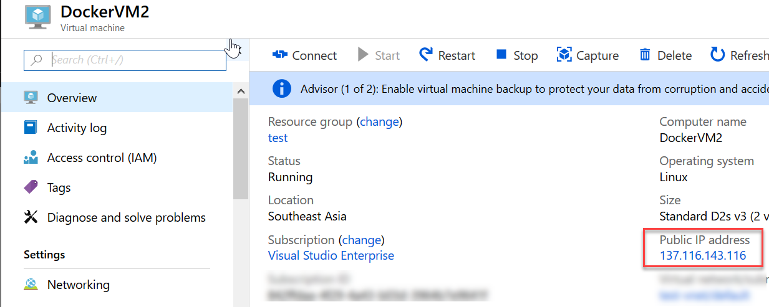

1. Connect using SSH client (Git Bash / Ubuntu bash)

$ ssh [dockeradmin@137.116.143.116](mailto:dockeradmin@137.116.143.116)

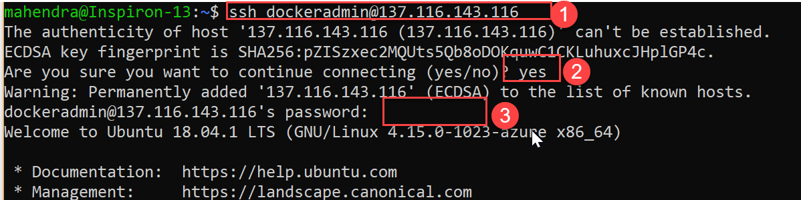

1. Verify docker installation using command:

$ docker -v

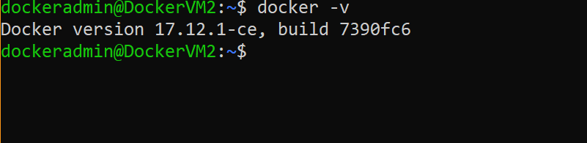

1. Download minikube from URL

$ curl -Lo minikube https://storage.googleapis.com/minikube/releases/latest/minikube-linux-amd64

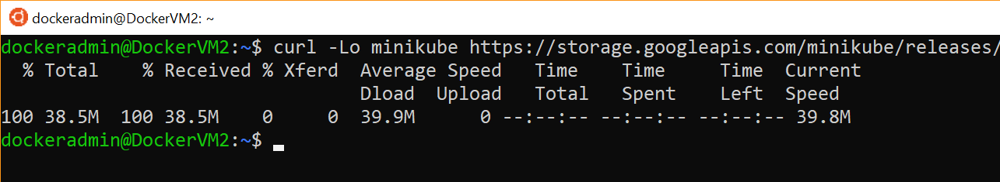

1. Make this file executable using command:

$ sudo chmod +x minikube

$ ls -l

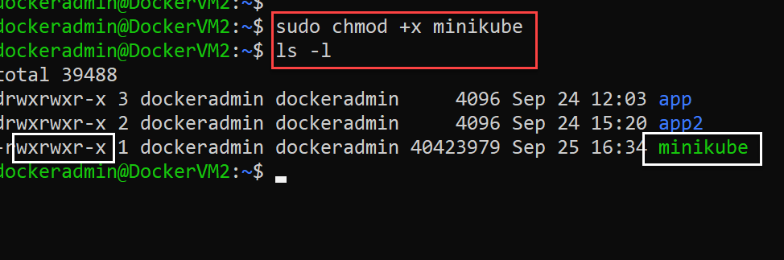

1. The “minikube” is now at user home directory, move it to /usr/local/bin to make it available from anywhere (directory path) in terminal.

NOTE : /usr/local/bin is already part of PATH env variable.

$ sudo mv minikube /usr/local/bin

1. Download another small utility called “kubectl” using similar approach

$ curl -LO https://storage.googleapis.com/kubernetes-release/release/v1.11.3/bin/linux/amd64/kubectl

$ chmod +x kubectl

$ sudo mv kubectl /usr/local/bin

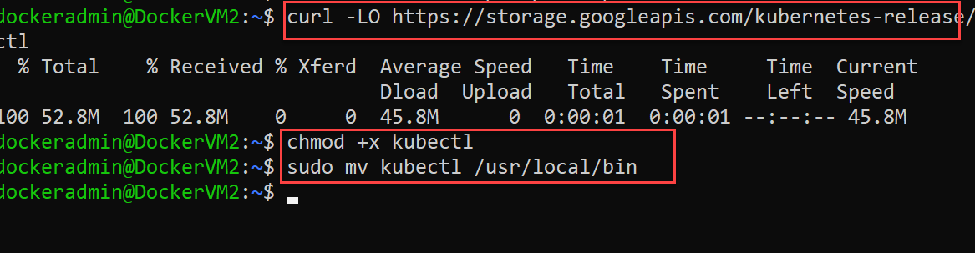

1. **Bootstrap single host cluster using minikube**
2. Verify the installation of minikube & kubectl by printing version

$ kubectl version

$ minikube version

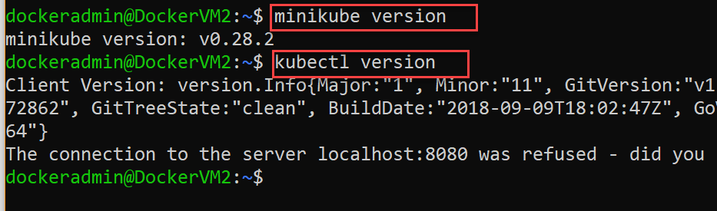

NOTE: Ignore the error reported by kubectl as of now.

1. Begin bootstrap with following command:

$ sudo minikube start --vm-driver=none

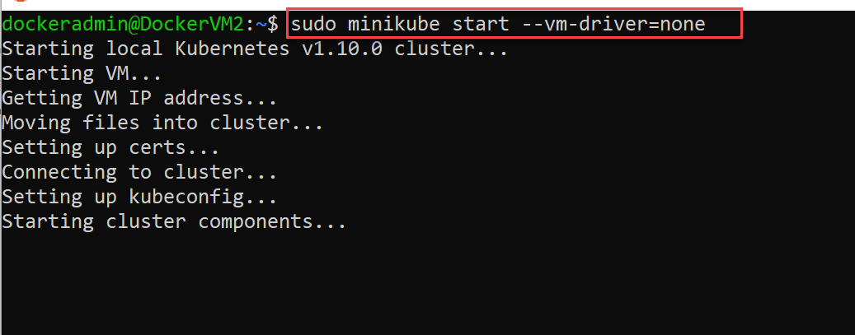

1. Now, change the owner for generate “.kube” directory.

$ sudo chown -R $USER:$USER .kube

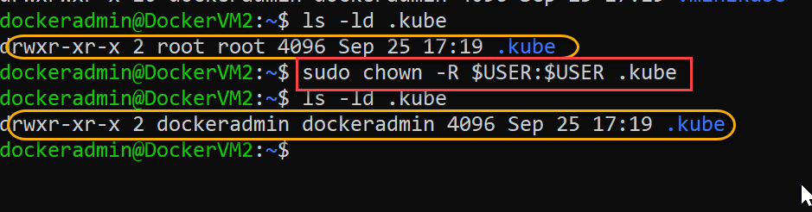

1. Try following command to list the nodes in cluster

$ sudo kubectl get nodes

NOTE: If you change owner of “.minikube” directory to current user ($USER), then “sudo” can be dropped from above command.

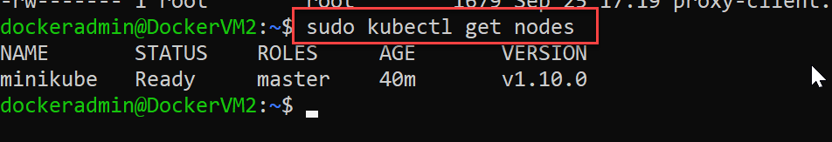

1. Check the cluster info

$ sudo kubectl cluster-info

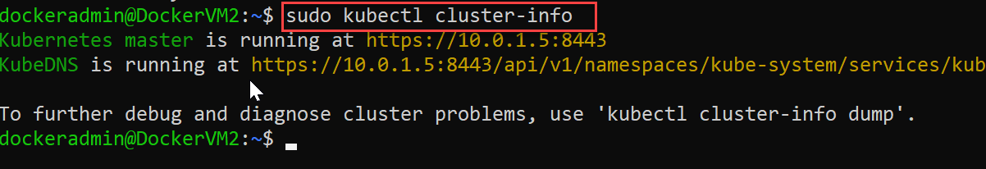

1. Launch kubernetes dashboard and open port for external access.
2. Goto Azure Portal to add new firewall rule to VM

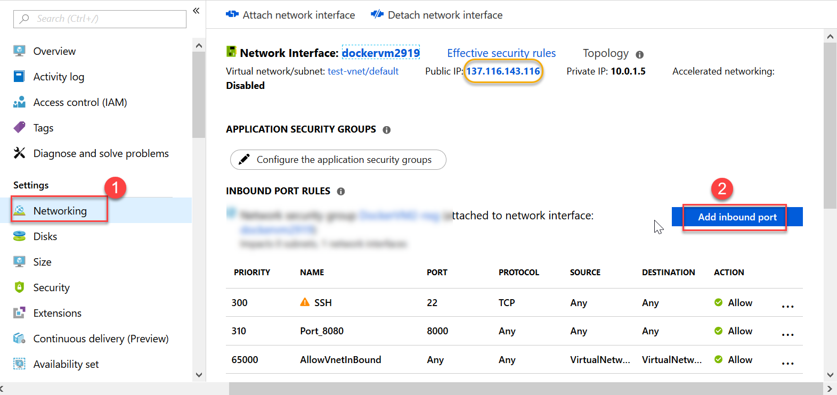

1. Add new rule for PORT 30000 and click “Add” button

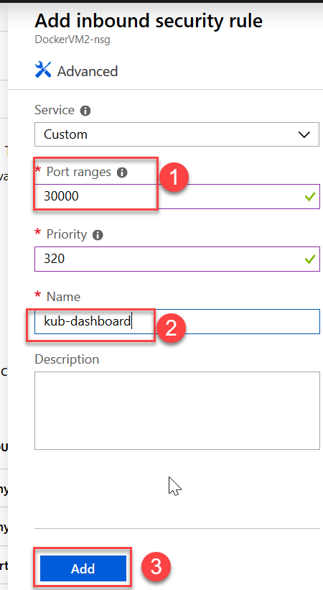

1. Switch to SSH session, type following command to start minikube dashboard

$ sudo minikube dashboard

1. In Step 2, you should have got public ip for VM
2. Try in browser:

<public-ip>:30000

Browser should load kubernetes dashboard like this one:

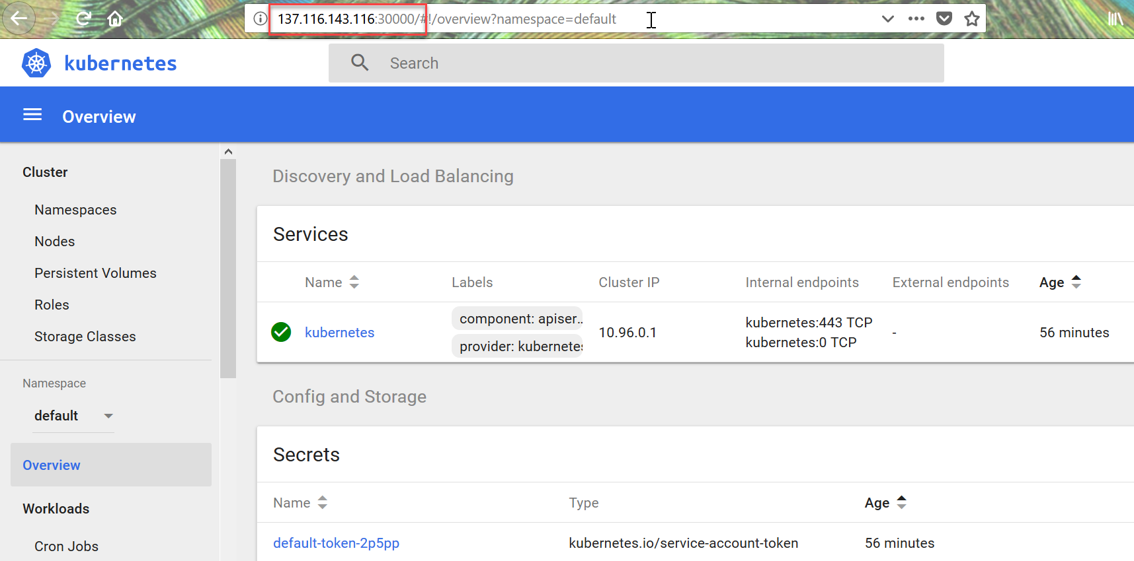

1. Shutdown minikube cluster before you shutdown the VM

$ sudo minikube stop